

**Dr. A.P.J. Abdul Kalam Technical University, Lucknow**

A

Project Report

on

**“Integrated Industrial Automation System”**

**Bachelor of Technology**

**in**

**Electronics & Communication Engineering**

Under the guidance of

**Prof. Praveen Chaurasia**

**(Assistant Professor)**

Submitted by

**Kritika Nath (1814331026)**

**Prabhat Mittal (1814331036)**

**Nitesh Upadhyay (1814331035)**

# Mudit Pratap Singh (1814331029)

of

**Department Electronics & Communication Engineering**

**IMS Engineering College, Ghaziabad**

**January 2022**

**CONTENT**

Acknowledgement ......................................................................................................03

Abstract.......................................................................................................................04

Introduction.................................................................................................................05

Literature Review........................................................................................................06

1. Bluetooth based home automation system using cell phones........................06
2. Zigbee based home automation system using cell phone...............................07
3. GSM based home automation system using cell phones.................................08
4. Wi-Fi based home automation system using cell phones................................09
5. Home automation using RF module................................................................10
6. Home automation using Android ADK ............................................................11
7. Cloud Based home automation system...........................................................12
8. Raspberry pi home automation with wireless sensors using smart phone.....14
9. Sending Commands to the Raspberry Pi .........................................................14
10. Receiving Data from the Raspberry Pi..............................................................15
11. Wireless Home Automation system using IoT..................................................16

Done Work...................................................................................................................17

Remaining Work..........................................................................................................17

Results and Conclusions..............................................................................................18

Future Scope and Application......................................................................................19

1. Home Is Where the Smart Is.............................................................................19
2. Lighting Control: Leaving the Dark Ages and Stepping into the Light...............19
3. HVAC Regulation: No Longer Burned by Your Heating Bill................................19
4. Security Systems...............................................................................................20

References....................................................................................................................21

**\*\*\***

**ACKNOWLEDGEMENT**

Date: 03-02-2022

We would like to express my sincere thanks to Mr. Praveen Chaurasia, for his valuable guidance and support in completing my project.

We would also like to express my gratitude towards our HOD ECE, **Dr. Pankaj Goel** for giving us this great opportunity to do a project on Integrated Industrial Automation System. Without their support and suggestions, this project would not have been completed.

Signature:

Guide Name : Prof. Praveen Chaurasia

Student Name:

* Mudit Pratap Singh
* Prabhat Mittal
* Kritika Nath
* Nitesh Upadhyay

Signature

(HOD ECE)

**ABSTRACT**

Automation was initially used in Industries to reduce the human exposure to hazardous situations and to have work done more effectively and efficiently. Its use reduced the man-power required, and also helped in handling complex systems more effectively. In this project we have tried to bring a model of Industrial Automation for integrated purpose which is simple, reliable and cost-effective. By making use of the fact that mobile phones have become an inseparable part of our lives, in this model we have kept the mobile phone at the center of our system i.e. we have tried to automate the entire system with the help of a mobile phone. This Integrated Automation System is hugely expandable and is capable of handling several complex tasks in parallel. The idea behind making this project is to get a feeling of how an automation system can be automated completely with the help of a mobile phone.

**CHAPTER- 1**

**INTRODUCTION**

Automation is the use of machines, control systems and information technologies to optimize productivity in the production of goods and delivery of services. In the scope of industrialization, automation is a step beyond mechanization. Automation plays an increasingly important role in the world economy and in daily experience. Slowly automation has started penetrating our homes. Its presence can be felt in the TV remote controls, fire alarm systems, water tank management systems, and also in security systems. We have started relying on Automation to make our lives easy and secure. Automating Home helps in saving electricity, reduces manual labour, increases reliability and efficiency, and also helps in tackling security. Home automation for the elderly and disabled can provide increased quality of life for persons who might otherwise require caregivers or institutional care. The popularity of automation systems has been increasing greatly in recent years due to much higher affordability and simplicity though Smartphone and tablet connectivity. The concept of the "Internet of Things" has tied in closely with the popularization of the Integrated Automation System.

**Literature Review:**

**1. Bluetooth based home automation system using cell phones:**

In Bluetooth based home automation systems the home appliances are connected to the Arduino BT board at input output ports using relay. The program of the Arduino BT board is based on the high-level interactive C language of microcontrollers; the connection is made via Bluetooth. The password protection is provided so only authorized users are allowed to access the appliances. The Bluetooth connection is established between Arduino BT board and phone for wireless communication. In this system the python script is used and it can be installed on any of the Symbian OS environments, it is portable. One circuit is designed and implemented for receiving the feedback from the phone, which indicates the status of the device.

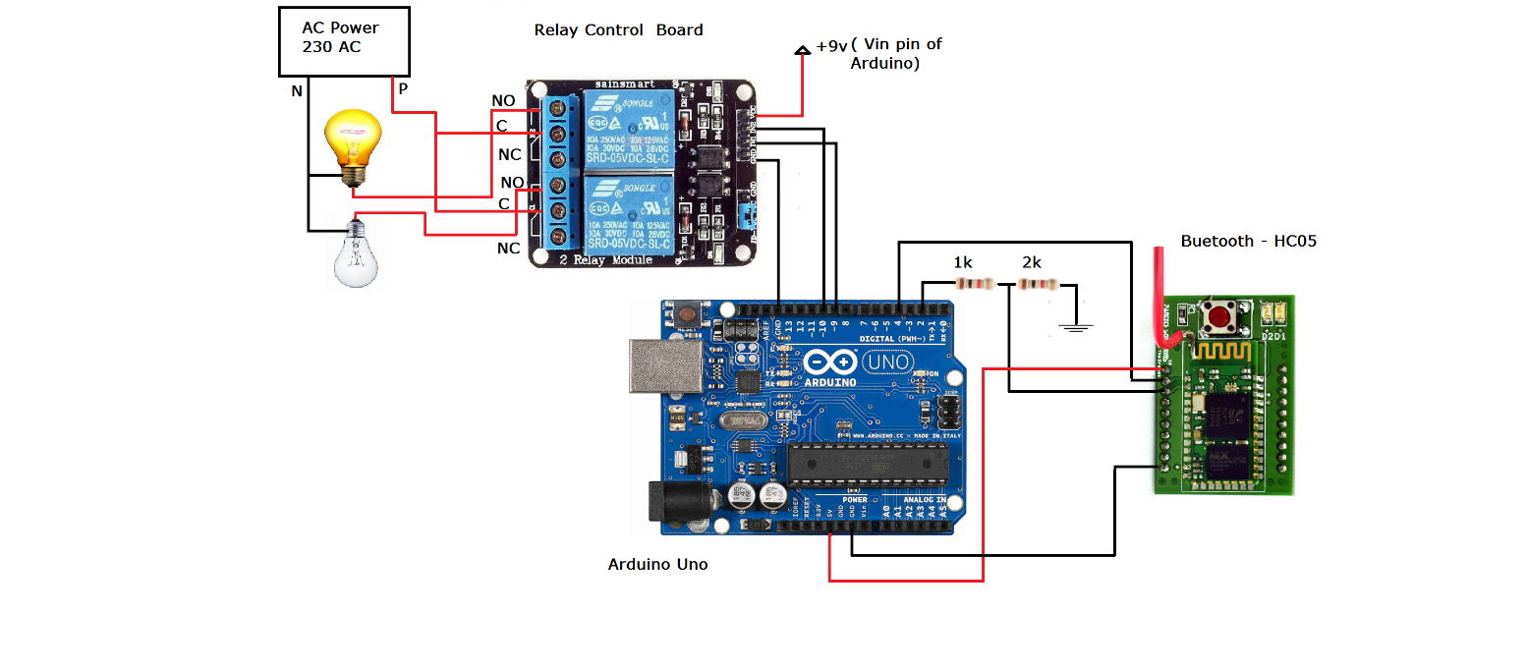

Figure 1:Bluetooth based home automation system using cell phones

**2.Zigbee based home automation system using cell phones:**

To monitor and control the home appliances the system is designed and implemented using Zigbee. The device performance is recorded and stored by network coordinators. For this the Wi-Fi network is used, which uses the 4- switch port standard wireless ADSL modem router. The network SSID and security Wi-Fi parameters are preconfigured. The message for security purposes is first processed by the virtual home algorithm and when it is declared safe it is re-encrypted and forward to the real network device of the home. Over the Zigbee network, the Zigbee controller sent messages to the end. The safety and security of all messages that are received by the virtual home algorithm. To reduce the expense of the system and the intrusiveness of respective installation of the system Zigbee communication is helpful.

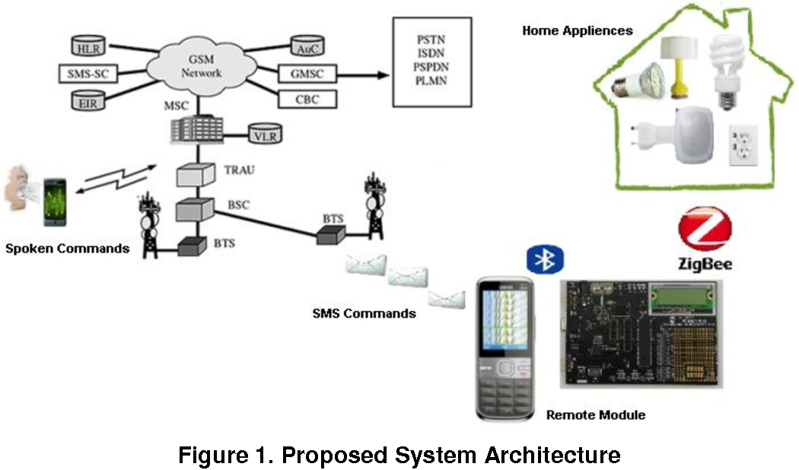

Figure 2:Zigbee based home automation system using cell phones

**3.GSM based home automation system using cell phones:**

Because of the mobile phone and GSM technology, the GSM based home automation is a lure to research. SMS based home automation, GPRS based home automation and dual tone multi frequency (DTMF) based home automation, these options we considered mainly for communication in GSM. The figure shows the logical diagram of the work of A. Alheraish, it shows how the home sensors and devices interact with the home network and communicates through GSM and SIM (subscriber identity module). The system uses a transducer which converts machine function into electrical signals which go into a microcontroller. The sensors of the system convert the physical qualities like sound, temperature and humidity into some other quantity like voltage. The microcontroller analyzes all signals and converts them into commands to be understood by the GSM module. Select appropriate communication methods among SMS, GPRS and DTFC based on the command which received the GSM module.

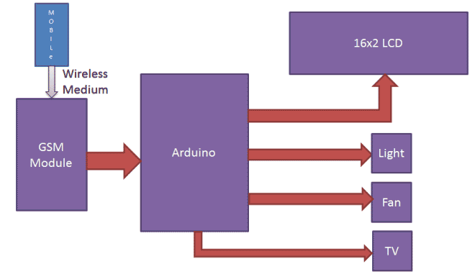

Figure 3:GSM based home automation system using cell phones

**4.Wi-Fi based home automation system using cell phones:**

Wi-Fi based home automation systems mainly consist of three modules, the server, the hardware interface module, and the software package. The figure shows the system model layout. Wi-Fi technology is used by server, and hardware Interface modules to communicate with each other. The same technology is used to login to the server web based application. The server is connected to the internet, so remote users can access server web based application through the internet using compatible web browser. Software of the latest home automation system is split to server application software, and Microcontroller (Arduino) firmware. The Arduino software, built using C language, using IDE comes with the microcontroller itself. Arduino software is culpable for gathering events from connected sensors, then applies action to actuators and pre pre-programmed in the server. Another job is to report the and record the history in the server DB. The server application software package for the proposed home automation system, is a web based application built using asp.net. The server application software can be accessed from internal network or from internet if the server has real IP on the internet using any internet navigator supports asp.net technology. Server application software is culpable of, maintain the whole home automation system, setup, configuration. Server uses a database to keep log of home automation system components, we choose to use XML files to save system log.

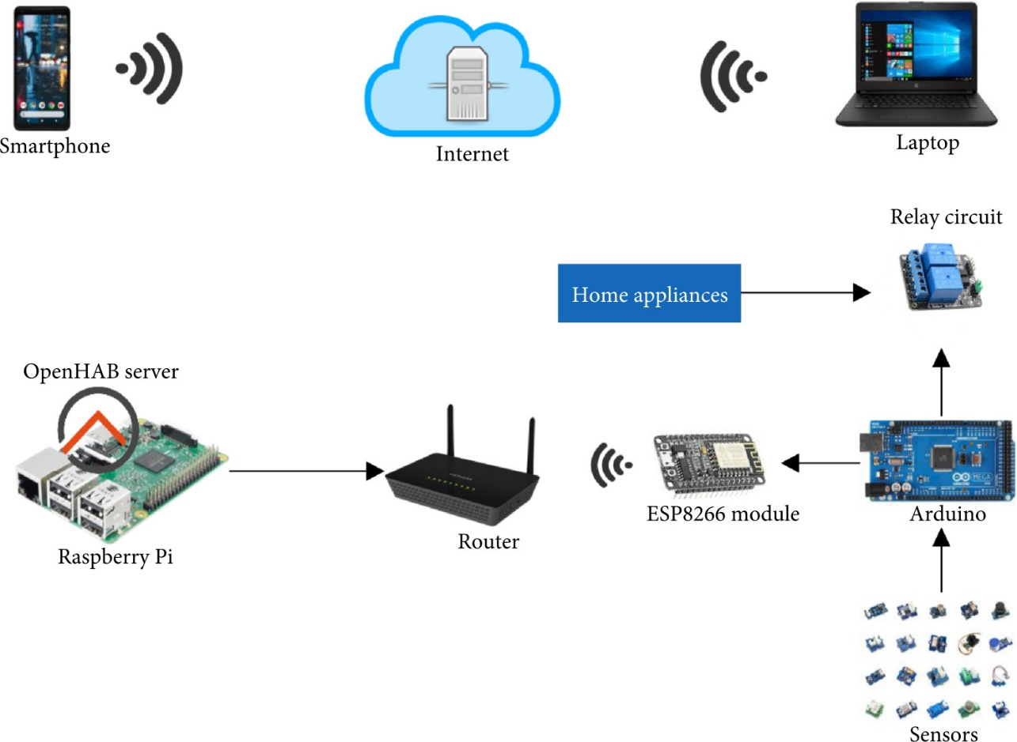

Figure 4:Wi-Fi based home automation system using cell phones

**5.Home automation using RF module:**

The important goal of Home Automation System is to build a home automation system using a RF controlled remote. Now technology is accelerating so homes are also getting smarter. Modern homes are deliberately relocating from current l switches to centralized control systems, containing RF controlled switches. Today Traditional wall switches situated in various parts of the home makes it laborious for the end user to go near them to control and operate. Even further it turns into more problematic for the old persons or physically handicapped people to do so. Home Automation using remote implements an easier solution with RF technology. In order to accomplish this, a RF remote is combined to the microcontroller on transmitter side that sends ON/OFF signals to the receiver where devices are connected. By operating the stated remote switch on the transmitter, the loads can be turned ON/OFF globally using wireless technology.

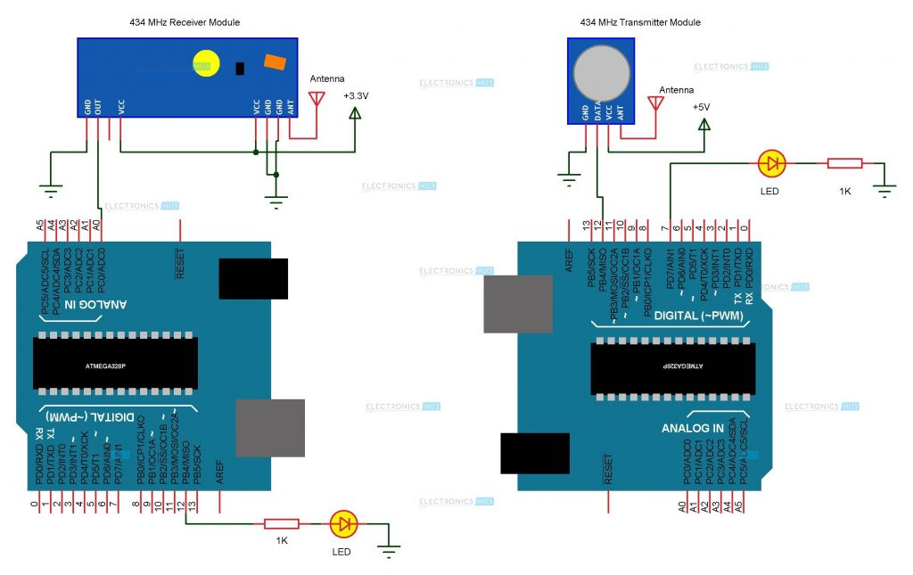

Figure 5:Home automation using RF module

**6.Home automation using Android ADK:**

The devices of home are associated with the ADK and the Connection is established between the Android device and ADK. The devices of the house are linked to the input/output ports of the board (EMBEDDED SYSTEM) and their current situation will have passed to the ADK. The microcontroller board (Arduino ADK) is based on the ATmega2560. It has a USB host connection to associate with Android based phones, and that is based on the MAX3421e IC. The two important features of Android Open Accessory Protocol 2.0(AOAP) are as follows: It has audio output that is from the Android device to the component and its support for the component serves as one or more Human Interface Devices (HID) to the Android device. This paper depends upon Android and Arduino platforms in which both are FOSS(Free Open Source Software). Including motion sensors for safety systems will detect an unauthorized action and it will automatically notify the user through cell phone or the security system.

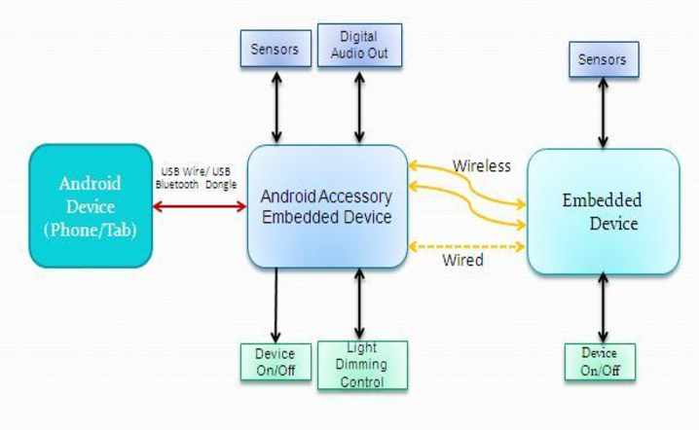

Figure 6:Home automation using Android ADK

**7.Cloud Based home automation system:**

Home Automation using cloud based system focuses on design and implementation of home gateway to collect data about data from home appliances and then send to the cloud-based data server to get store on Hadoop Distributed File System, it is process using MapReduce and use to implement a monitoring tasks to Remote user Presently home Automation System is persistently developing its resilience by assimilating the current characteristics which gratify the rising interest of the people. This paper presents the design and development of home automation systems that use cloud computing as a service. The current system consists of three important units: the first part is cloud server, handles and controls the data and information of client and users and the status of devices The hardware interface module is the second part which implements the relevant connection to the actuators and sensing devices which give the physical service. Last part is Home Server, which constructs the hardware device and gives the user interface. This paper focuses on building the web services using the cloud which is needed for security and storage and availability of the data. The current system is cost efficient, reliable and comfortable which also gives a secured home automation system for the entire family. The system is made up of various client modules for various platforms.

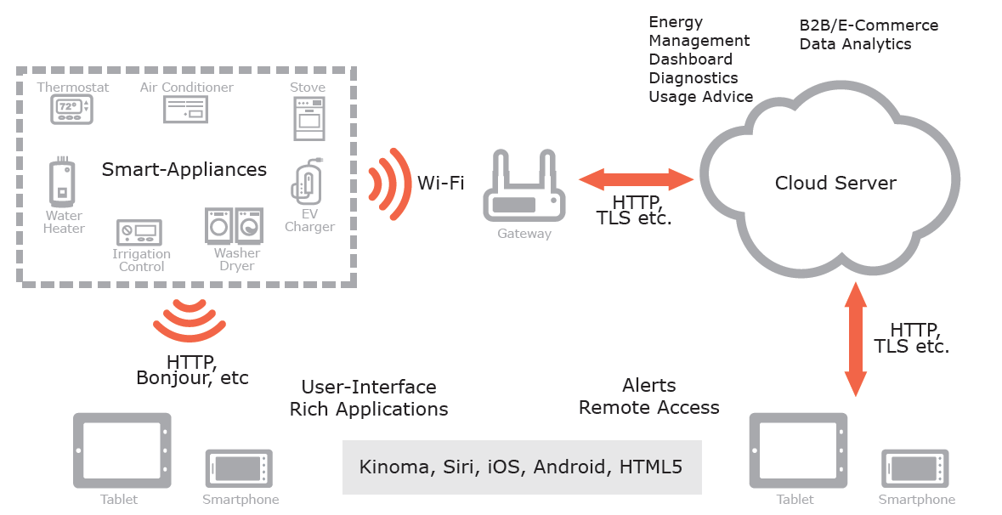

Figure 7:Cloud Based home automation system

1. Cloud server Cloud Server is a central server aimed at implementing services to the other sub modules. Central server serves as the data respiratory system and brain It implements three connections to the three sub modules vizhome system, web configuration tool and mobile. The server evaluates the data it takes from the house, sends current status to the mobile device and vice versa. A database is managed by the server and its status gets updated as per the changes done at home end.

2. Embedded Program for Hardware Circuit Microcontroller.

3. Internet Client for any desktop or mobile phones.

**8.Raspberry pi home automation with wireless sensors using smart phone:**

Home Automation System has been developed with Raspberry Pi by reading the algorithm and subject of Email. Raspberry Pi guarantees to be an efficient platform for implementation of powerful, and economic smart home automation. Home automation using Raspberry pi is better than any other home automation methods in several ways. For example, DTMF (dual tone multi-frequency) using home automation, the call tariff is a big demerit, which is not the problem in their proposed method. In Home Automation using web server, the design of web server and the memory space required is dismiss by this method, because it just uses the already established web server service given by G-mail. LEDs were used to identify the switching action. This System is efficient and flexible interactive.

**Sending Commands to the Raspberry Pi:**

The script running on the server side of our laptop or on a web server receives the input commands from the user and appropriately sends it to the client (Raspberry Pi). In This, we will be using those input commands to turn a light ON/OFF. When we give the command to turn ON a light by the server side script, the data and information gets relayed to the Raspberry Pi and its GPIO pin will turns ON a relay. The system can send current updates to the server to detect whether the light is ON/OFF.

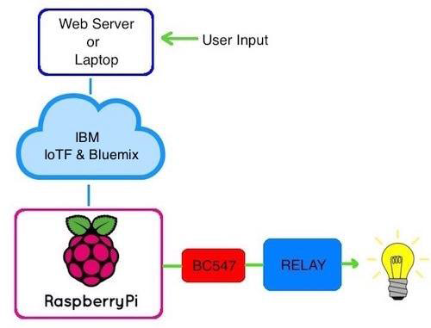

Figure 8:Sending Commands to the Raspberry Pi

**Receiving Data from the Raspberry Pi :**

Using PIR motion sensor we can send the data signal to the Raspberry Pi, we just run a script which can reads the sensor by a GPIO pin and transmit the data to overall system through the IoTF platform. This can then be looked at by the IoT console.

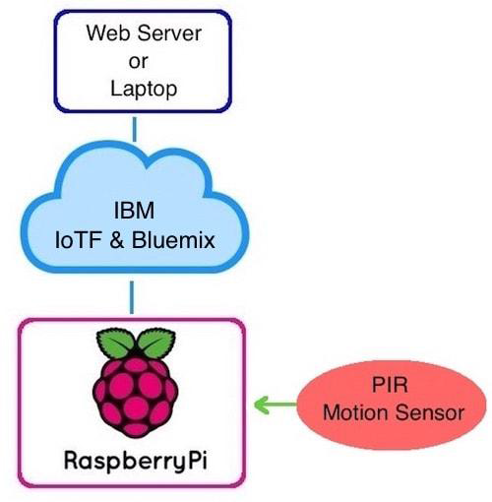

Figure 9:Receiving Data from the Raspberry Pi

**9. Wireless Home Automation system using IoT:**

This system uses mobiles or computers to control basic home control and function automatically through the internet from anywhere around the world globally, an automated home is sometimes called a smart home. It is meant to save the electric power and human energy. The proposed system is a distributed home automation system, consists of server i.e. Wi-Fi module, sensors. Server controls and monitors the various sensors, and can be easily configured to handle more hardware interface module (sensors). The Arduino board, with built in Wi-Fi module acts as web server. Automation System can be accessed from the web browser of any local PC using server IP, or remotely from any PC or mobile handheld device connected to the internet with appropriate web browser through server real IP (internet IP). Wi-Fi technology is selected to be the network infrastructure that connects server and the sensors. Wi-Fi is chosen to improve system security (by using secure Wi-Fi connection), and to increase system mobility and scalability.

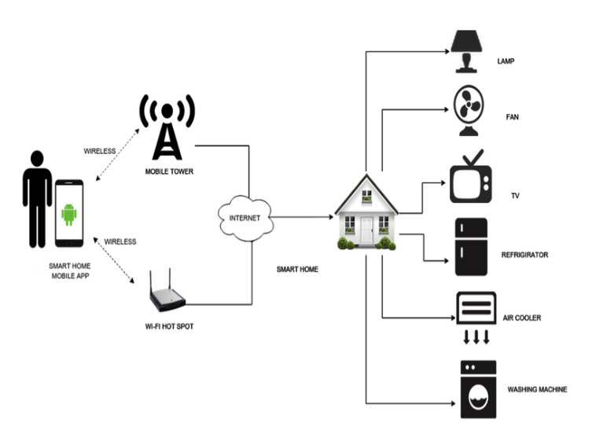

Figure 10:Wireless Home Automation system using IoT

**CHAPTER- 2**

**Done Work:**

1. Circuit Implementation of Both circuit Part
2. Hardware implementation for 1st circuit board
3. Programming for 1st circuit board
4. Implementation
5. Software Testing
6. Hardware Testing

**Still Remaining Work:**

1. Hardware Implementation of second Board
2. Programming for 2nd board
3. Final testing

**CHAPTER- 3**

**(Results and Conclusions)**

Result of hardware implementation, programming and testing for first Circuit Board is Positive all stages are clear including testing and now we are working on second circuit board programming and testing is still remaining.

Industrial automation system techniques use wireless technology Node-MCU based home automation techniques have been implemented in order to provide ease to the people to control their home appliances. Different home automation techniques using Arduino, GSM and Android are given with their design, implementation and flowcharts which gives the successful layout of their strengths and weaknesses Main purpose of home automation system is to provide ease to people to control different home appliances with the help of the android application present in their mobile phones and to save electricity, time and money. This system also helps the user to protect their homes from burglars when they are away from the home by using alarm as the alarm will start ringing whenever a burglar tries to enter the house and the person will receive a message on his mobile phone whenever some other person will try to enter the owner’s house, This system is also used to display the count of number of persons entering the house on LCD screen.

**CHAPTER – 4**

**(Future Scope and Application)**

**Home Is Where the Smart Is**

Evmachine-to-machine communication, and you understand you’re not the most tech-savvy consumer, it’s impossible that you’ve missed the abundance of home automation products filling the shelves and ads of every home improvement store. Suddenly an ordinary errand for light bulbs will leave you wondering if your lamp could send you a message alerting you that the light bulb needs to be replaced. Furthermore, if your lamp is talking to you, could your refrigerator and sprinkler system be too? Experts say: Yes, the possibilities are endless. If that’s the case, where do you begin?

Any day-to-day, repeatable process is automatable with smart home applications. The greater the control and flexibility of these processes, the more energy and cost savings the resident experiences, which are factors anyone who pays utilities strives to moderate. The smart home revolution is likely to be more of an evolution, with the incorporation of one or two home systems at a time, gradually automating our households through smart mobile devices. However, with these elements of efficiency comes the question of ease of use. Will it bring you enjoyment or exasperation? With so many brands and models already available in an ever-growing market, how do you know which is best for you?

**Lighting Control: Leaving the Dark Ages and Stepping Into the Light**

Smart lighting allows you to control wall switches, blinds, and lamps, but how intuitive is a lighting control system? It turns out, quite; its capabilities are extensive. You’re able to schedule the times lights should turn on and off, decide which specific rooms should be illuminated at certain times, select the level of light which should be emitted, and choose how particular lights react through motion sensitivity, as seen with Belkin’s WeMo Switch + Motion, which is both affordable and easy to use with its plug-and-play simplicity.

**HVAC Regulation: No Longer Burned by Your Heating Bill:**

As fuel costs rise and the availability and sustainability of our resources becomes a greater concern, heating/cooling our homes efficiently is less a budgetary bonus and more of a necessity. Over the past year, smart thermostats and automated home heating systems have become more readily available and easily incorporate into any home. Heating and cooling our homes consumes an average of 50% of energy costs yearly, making daily HVAC regulation progressively rewarding. Maintaining a substantial lead among the nearly non-existent competition, the Nest Learning Thermostat, learns your heating and cooling preferences over time, eliminating the need for programming and is accessible from your smartphone app. With automated HVAC you are able to reduce the heat when a room is unoccupied, and increase or decrease it at specific times based on your schedule and occupancy.

**Security Systems:**

Who’s there? The Internet of Things. While efficiency and conservation are certainly IoT benefits, its potential to have improved control over home security is a primary focus. Smart locks, like Kwikset’s Kevo, a Bluetooth enabled electronic deadbolt, and various connected home security systems, such as iSmartAlarm, offer a variety of features including door and window sensors, motion detectors, video cameras and recording mechanisms. All of which are connected to a mobile device and accessible via the cloud, thus enabling you to access real-time information on the security status of your home. Naturally, there is a great deal of scrutiny regarding the level of trust in controlling your home’s security system via a mobile device, but it begs earnest exploration when weighing the potential benefits and peace of mind it provides homeowners.

**REFERENCES**

* https://learn.adafruit.com/all-the-internet-of-things-episode-four-adafruit-io
* https://www.researchgate.net/publication/221270872_Amarino_A_toolkit_for_the_rapid_prototyping_of_mobile_ubiquitous_computing
* https://search.arduino.cc/search?q=home%20automation%20arduino&tab=projecthub
* https://github.com/search?q=home+automation
* https://www.electronicshub.org/home-automation-projects/
* https://iotcircuithub.com/nodemcu-esp8266-blynk-home-automation/

**\*\*\***